**2. Implement Ingress NVR Demo**

--- Reference - <https://github.com/stacksimplify/aws-eks-kubernetes-masterclass/tree/master/08-NEW-ELB-Application-LoadBalancers/08-09-NameBasedVirtualHost-Routing>

**Introduction**

--- Implement Host Header routing using Ingress

--- We can also call it has name based virtual host routing

**Review Ingress Manifests for Host Header Routing**

--- File Name: 04-ALB-Ingress-HostHeader-Routing.yml

# Annotations Reference: https://kubernetes-sigs.github.io/aws-load-balancer-controller/latest/guide/ingress/annotations/

apiVersion: networking.k8s.io/v1

kind: Ingress

metadata:

  name: ingress-namedbasedvhost-demo

  annotations:

    # Load Balancer Name

    alb.ingress.kubernetes.io/load-balancer-name: namedbasedvhost-ingress

    # Ingress Core Settings

    #kubernetes.io/ingress.class: "alb" (OLD INGRESS CLASS NOTATION - STILL WORKS BUT RECOMMENDED TO USE IngressClass Resource)

    alb.ingress.kubernetes.io/scheme: internet-facing

    # Health Check Settings

    alb.ingress.kubernetes.io/healthcheck-protocol: HTTP

    alb.ingress.kubernetes.io/healthcheck-port: traffic-port

    #Important Note:  Need to add health check path annotations in service level if we are planning to use multiple targets in a load balancer

    alb.ingress.kubernetes.io/healthcheck-interval-seconds: '15'

    alb.ingress.kubernetes.io/healthcheck-timeout-seconds: '5'

    alb.ingress.kubernetes.io/success-codes: '200'

    alb.ingress.kubernetes.io/healthy-threshold-count: '2'

    alb.ingress.kubernetes.io/unhealthy-threshold-count: '2'

    ## SSL Settings

    alb.ingress.kubernetes.io/listen-ports: '[{"HTTPS":443}, {"HTTP":80}]'

    alb.ingress.kubernetes.io/certificate-arn: arn:aws:acm:us-east-1:180789647333:certificate/632a3ff6-3f6d-464c-9121-b9d97481a76b

    #alb.ingress.kubernetes.io/ssl-policy: ELBSecurityPolicy-TLS-1-1-2017-01 #Optional (Picks default if not used)

    # SSL Redirect Setting

    alb.ingress.kubernetes.io/ssl-redirect: '443'

    # External DNS - For creating a Record Set in Route53

    external-dns.alpha.kubernetes.io/hostname: default101.stacksimplify.com

spec:

  ingressClassName: my-aws-ingress-class   # Ingress Class

  defaultBackend:

    service:

      name: app3-nginx-nodeport-service

      port:

        number: 80

  rules:

    - host: app101.stacksimplify.com

      http:

        paths:

          - path: /

            pathType: Prefix

            backend:

              service:

                name: app1-nginx-nodeport-service

                port:

                  number: 80

    - host: app201.stacksimplify.com

      http:

        paths:

          - path: /

            pathType: Prefix

            backend:

              service:

                name: app2-nginx-nodeport-service

                port:

                  number: 80

# Important Note-1: In path based routing order is very important, if we are going to use  "/*", try to use it at the end of all rules.

# 1. If  "spec.ingressClassName: my-aws-ingress-class" not specified, will reference default ingress class on this kubernetes cluster

# 2. Default Ingress class is nothing but for which ingress class we have the annotation `ingressclass.kubernetes.io/is-default-class: "true"`

--- **01-Nginx-App1-Deployment-and-NodePortService.yml**

apiVersion: apps/v1

kind: Deployment

metadata:

  name: app1-nginx-deployment

  labels:

    app: app1-nginx

spec:

  replicas: 1

  selector:

    matchLabels:

      app: app1-nginx

  template:

    metadata:

      labels:

        app: app1-nginx

    spec:

      containers:

        - name: app1-nginx

          image: stacksimplify/kube-nginxapp1:1.0.0

          ports:

            - containerPort: 80

---

apiVersion: v1

kind: Service

metadata:

  name: app1-nginx-nodeport-service

  labels:

    app: app1-nginx

  annotations:

#Important Note:  Need to add health check path annotations in service level if we are planning to use multiple targets in a load balancer

    alb.ingress.kubernetes.io/healthcheck-path: /app1/index.html

spec:

  type: NodePort

  selector:

    app: app1-nginx

  ports:

    - port: 80

      targetPort: 80

--- **02-Nginx-App2-Deployment-and-NodePortService.yml**

apiVersion: apps/v1

kind: Deployment

metadata:

  name: app2-nginx-deployment

  labels:

    app: app2-nginx

spec:

  replicas: 1

  selector:

    matchLabels:

      app: app2-nginx

  template:

    metadata:

      labels:

        app: app2-nginx

    spec:

      containers:

        - name: app2-nginx

          image: stacksimplify/kube-nginxapp2:1.0.0

          ports:

            - containerPort: 80

---

apiVersion: v1

kind: Service

metadata:

  name: app2-nginx-nodeport-service

  labels:

    app: app2-nginx

  annotations:

#Important Note:  Need to add health check path annotations in service level if we are planning to use multiple targets in a load balancer

    alb.ingress.kubernetes.io/healthcheck-path: /app2/index.html

spec:

  type: NodePort

  selector:

    app: app2-nginx

  ports:

    - port: 80

      targetPort: 80

--- **03-Nginx-App3-Deployment-and-NodePortService.yml**

apiVersion: apps/v1

kind: Deployment

metadata:

  name: app3-nginx-deployment

  labels:

    app: app3-nginx

spec:

  replicas: 1

  selector:

    matchLabels:

      app: app3-nginx

  template:

    metadata:

      labels:

        app: app3-nginx

    spec:

      containers:

        - name: app2-nginx

          image: stacksimplify/kubenginx:1.0.0

          ports:

            - containerPort: 80

---

apiVersion: v1

kind: Service

metadata:

  name: app3-nginx-nodeport-service

  labels:

    app: app3-nginx

  annotations:

#Important Note:  Need to add health check path annotations in service level if we are planning to use multiple targets in a load balancer

    alb.ingress.kubernetes.io/healthcheck-path: /index.html

spec:

  type: NodePort

  selector:

    app: app3-nginx

  ports:

    - port: 80

      targetPort: 80

**Deploy all Application Kubernetes Manifests and Verify**

**# Deploy kube-manifests**

--- **kubectl apply -f kube-manifests/**

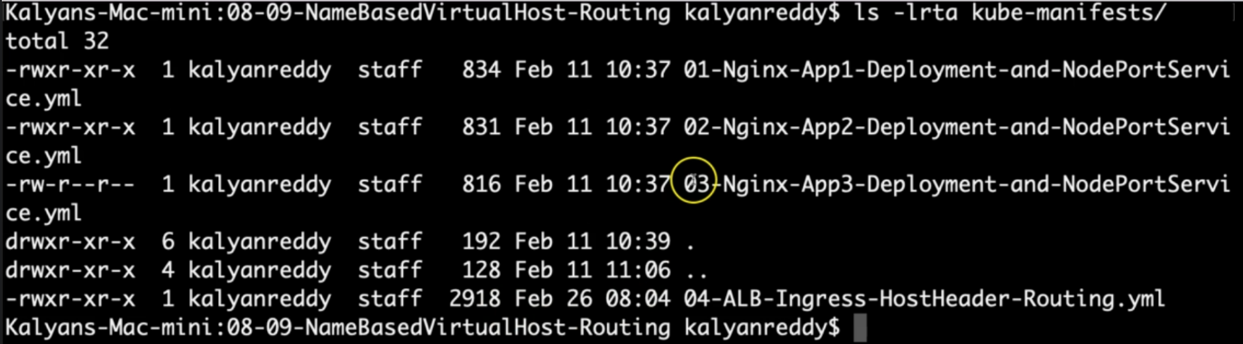

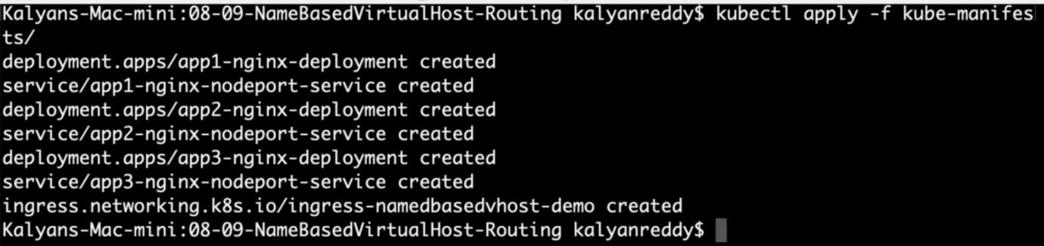

**# Verify Ingress Resource**

--- **kubectl get ingress**

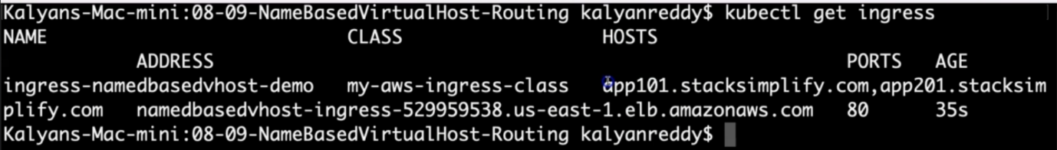

--- **note** – in host section, it is automatically discovering the sub domains. **App101.stacksimplify.com**, **app201.stacksimplify.com**. here you can see the end point load balancer.

**# Verify Apps**

--- **kubectl get deploy**

--- **kubectl get pods**

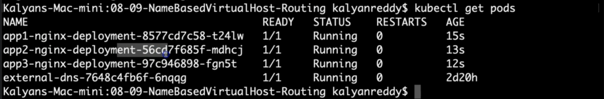

**# Verify NodePort Services**

--- **kubectl get svc**

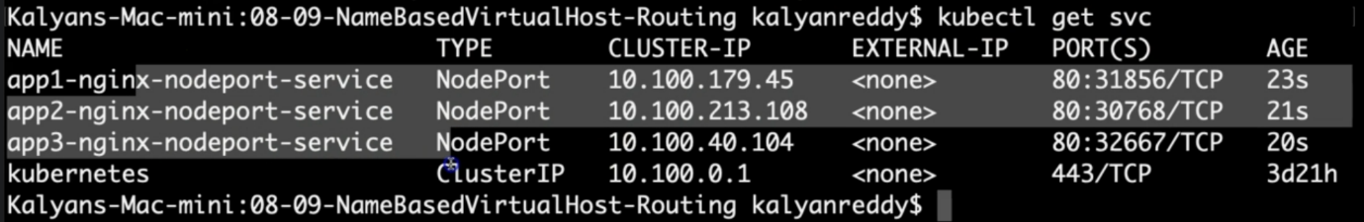

**Verify Load Balancer & Target Groups**

--- Load Balancer - Listeners (Verify both 80 & 443)

--- Load Balancer - Rules (Verify both 80 & 443 listeners)

--- Target Groups - Group Details (Verify Health check path)

--- Target Groups - Targets (Verify all 3 targets are healthy)

**Verify External DNS Log**

**# Verify External DNS logs**

--- **kubectl logs -f $(kubectl get po | egrep -o 'external-dns[A-Za-z0-9-]+')**

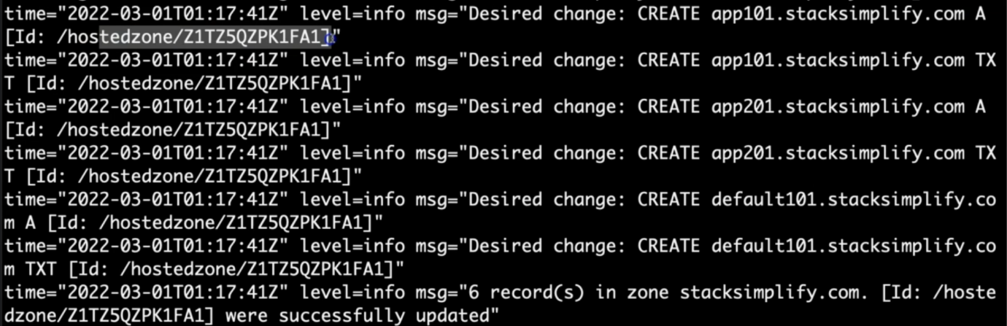

--- these logs can show us that it is going to create 3 things for us.

--- it showing that the app101.stacksimplify.com, app101.stacksimplify.com and default.101.stacksimplify.com are added to hosted zones. These 3 records were successfully added to Route53.

**Verify Route53**

--- Go to Services -> Route53

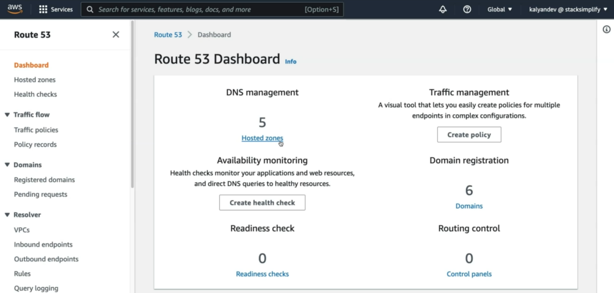

--- click on the hosted zones.

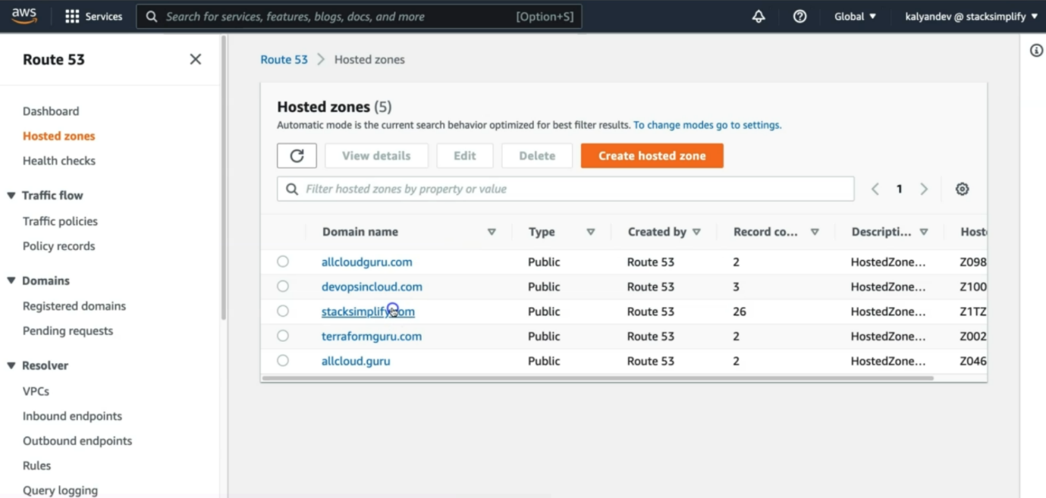

--- we need to go to the hosted zone **stacksimplify.com**.

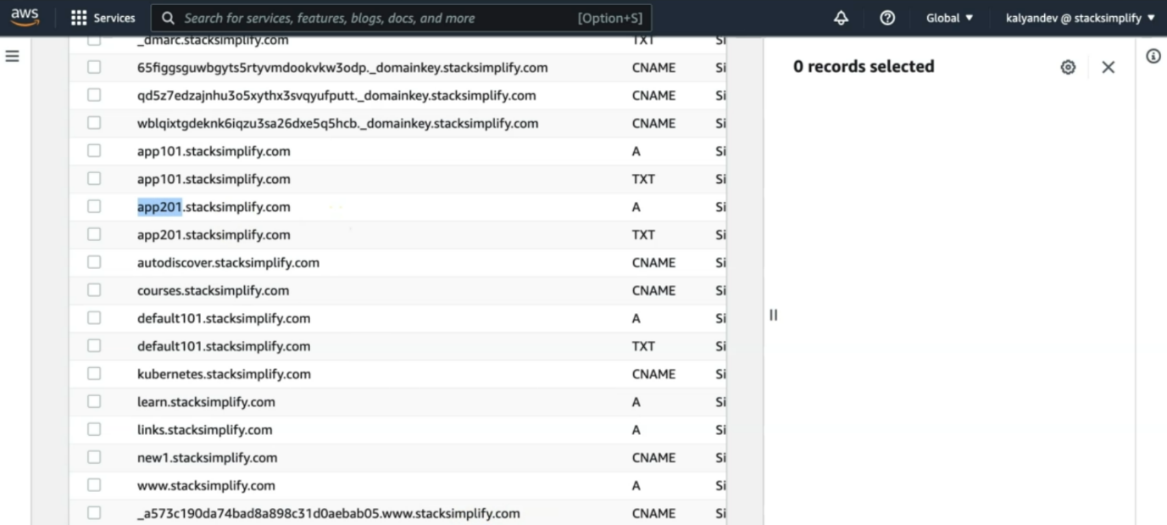

--- You should see Record Sets added for

1. default101.stacksimplify.com
2. app101.stacksimplify.com
3. app201.stacksimplify.com

--- **note** – all the sub domains are reference to ingress service. All these 3 sub domains are reference to the same ingress service.

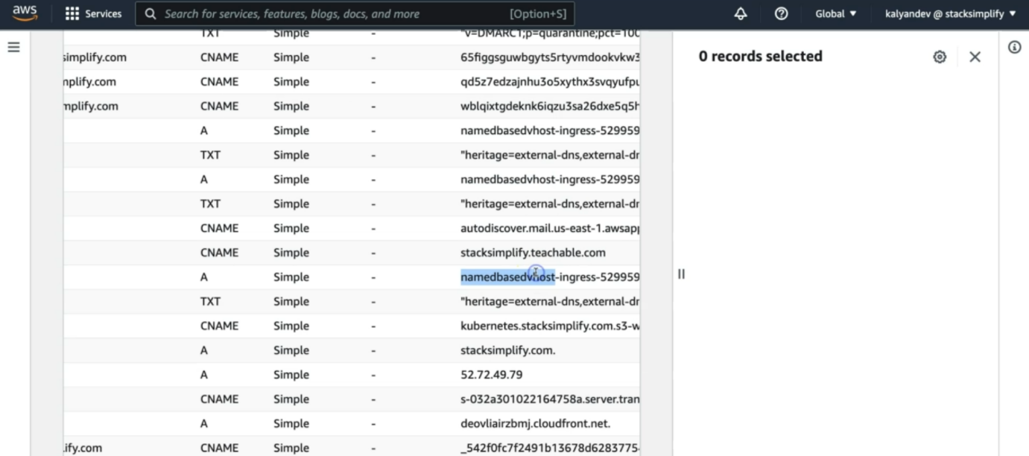

**Load balancer listeners**

--- go to load balancer > listeners

--- 1st we will see for HTTP: 80

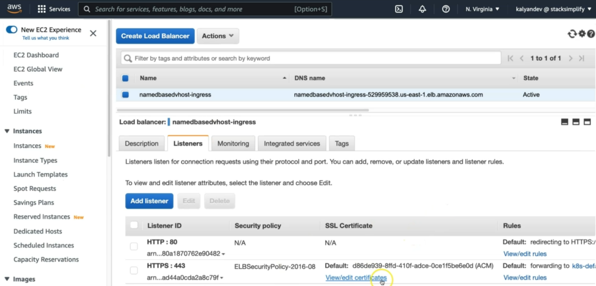

--- Click on **HTTP:80** view/edit rules.

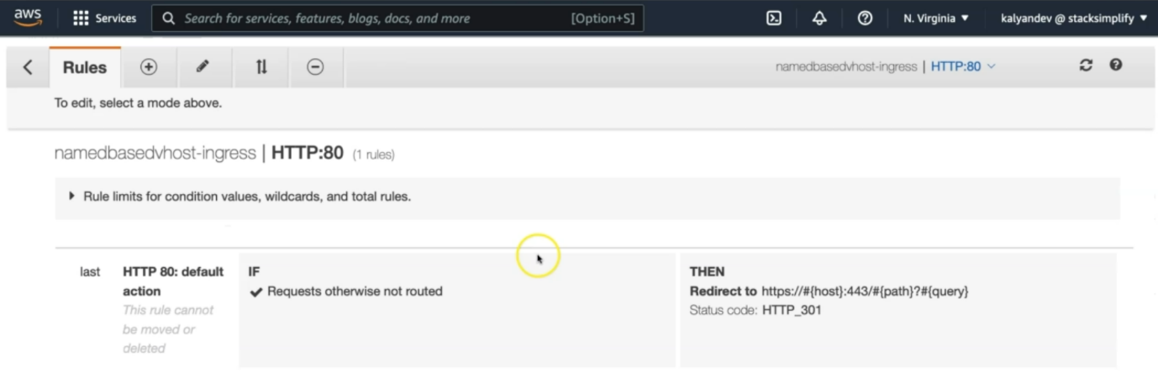

--- it is directing to **https:443** because we mentioned this rule in ingress service manifest.

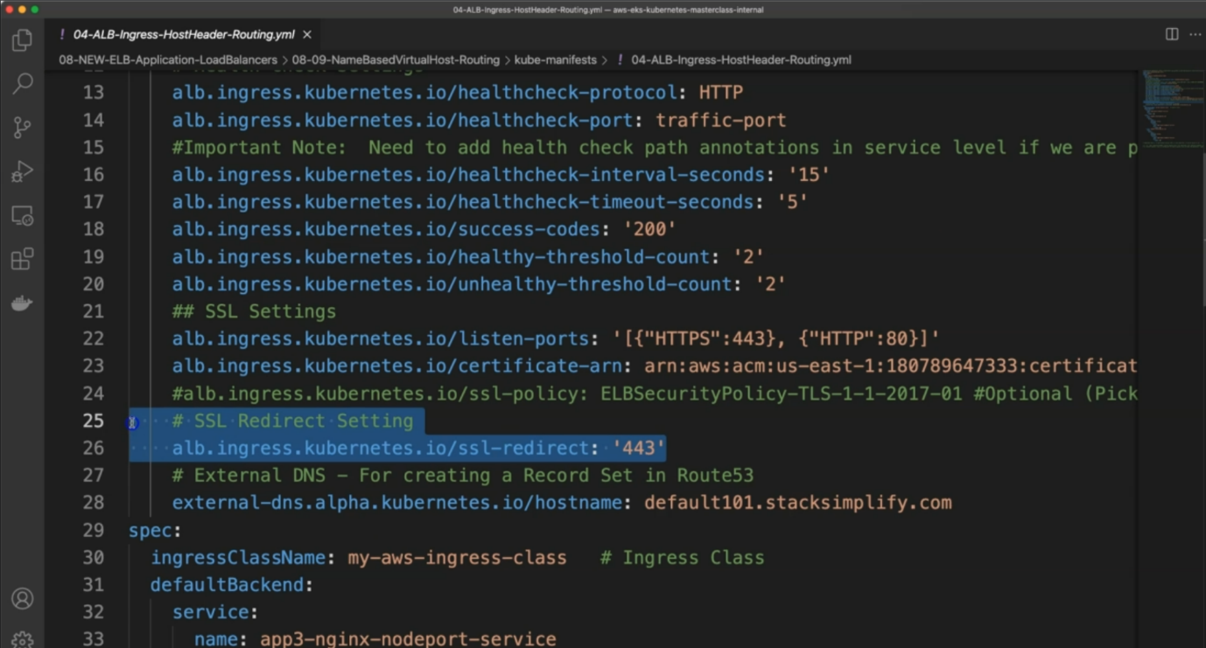

--- Click on **HTTP:443** view/edit rules.

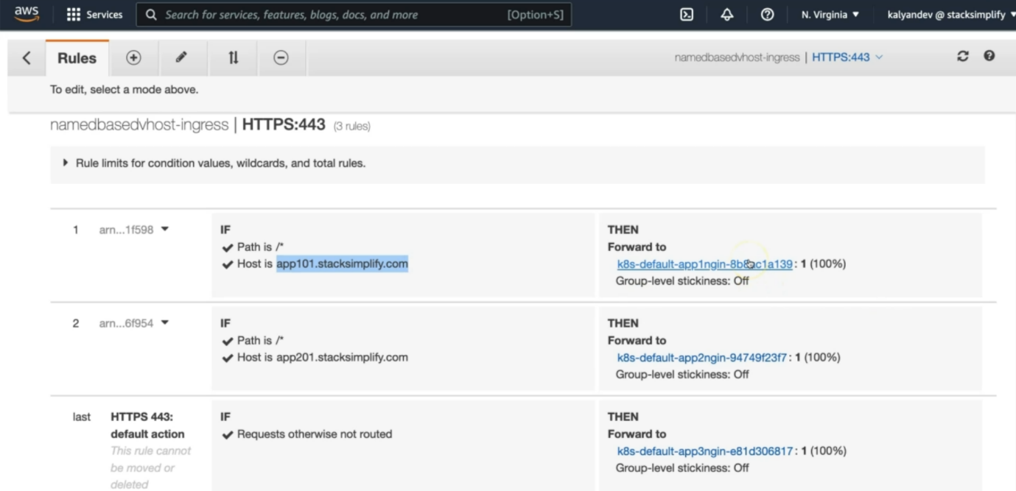

--- when your host is app101.stacksimplify.com then go to the k8s-default-app1 nginx related target group.

--- when your host is app102.stacksimplify.com then go to the k8s-default-app2 nginx related target group.

--- anything default go to k8s-default-app3nginx.

--- **note** – go to the target groups and see if they are healthy.

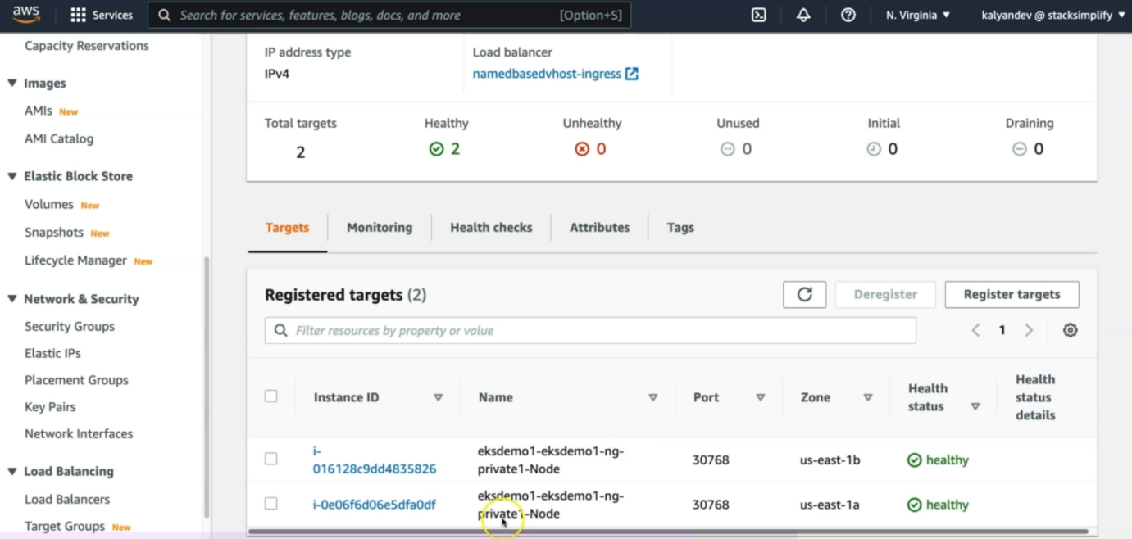

**Access Application using newly registered DNS Name**

--- Perform nslookup tests before accessing Application

--- Test if our new DNS entries registered and resolving to an IP Address

**# nslookup commands**

--- nslookup default101.stacksimplify.com

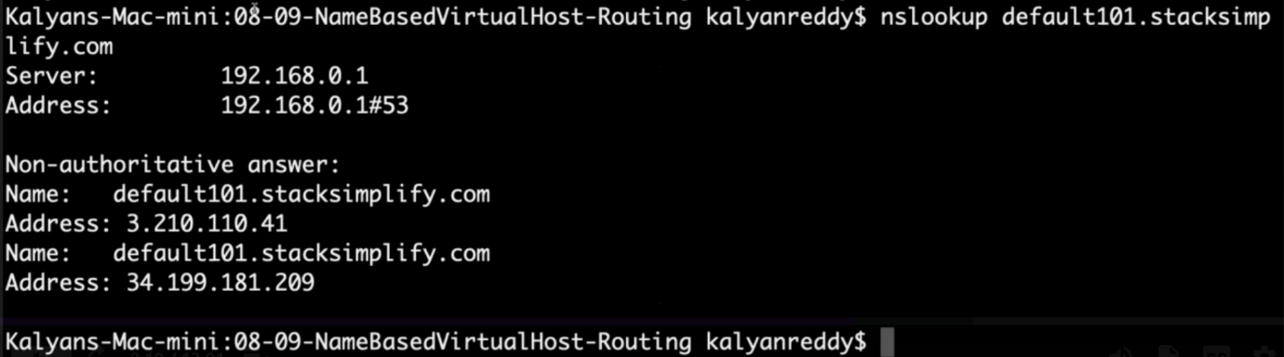

--- the dns is resolving to an ip address.

--- nslookup app101.stacksimplify.com

--- nslookup app201.stacksimplify.com

**Positive Case: Access Application using DNS domain**

**# Access App1**

--- <http://app101.stacksimplify.com/app1/index.html>

**# Access App2**

--- <http://app201.stacksimplify.com/app2/index.html>

**# Access Default App (App3)**

--- <http://default101.stacksimplify.com>

**Negative Case: Access Application using DNS domain**

**# Access App2 using App1 DNS Domain**

--- http://app101.stacksimplify.com/app2/index.html -- SHOULD FAIL

**# Access App1 using App2 DNS Domain**

--- http://app201.stacksimplify.com/app1/index.html -- SHOULD FAIL

**# Access App1 and App2 using Default Domain**

--- http://default101.stacksimplify.com/app1/index.html -- SHOULD FAIL

--- http://default101.stacksimplify.com/app2/index.html -- SHOULD FAIL

**Clean Up**

**# Delete Manifests**

--- **kubectl delete -f kube-manifests/**

**## Verify Route53 Record Set to ensure our DNS records got deleted**

--- Go to Route53 -> Hosted Zones -> Records

--- the below records should be deleted automatically

1. default101.stacksimplify.com

2. app101.stacksimplify.com

3. app201.stacksimplify.com